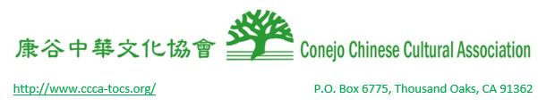
CCCA Student Commission Application Guidelines

I. PROGRAM DESCRIPTION

CCCA is a nonprofit organization that promotes the well-being of the local Chinese-American community by leading and sponsoring cultural, civic and educational activities. CCCA is run entirely by volunteers and operated by an elected board of directors.

The Student Commission Program is a group of young cultural ambassadors to reach out to the vast number of young Americans in our community to achieve the following defined objectives, the mission and the vision statements. The term is minimum one year to maximum 3 years from July 1 to June 30.

Objectives:
- Through cultural outreach, better understand the commonalities and uniquities of youth from diverse backgrounds.
- Empower youth to execute innovative ideas by creating opportunities and maximizing available resources.
Mission Statement:
- Inspire youth to serve and unite the local communities.
Vision Statement:
- Create a new horizon in leadership.
II. PROGRAM ELIGIBILITY

To be eligible to apply for the position, a student must satisfy the following standards:

- Must be in grade 9th to11th.
- Must be responsible, goal-oriented and committed to community service.
- Must have an interest or understanding of Chinese culture and language.
- Student commissioner candidate, if selected, is required to be a CCCA member.

III. APPLICATION DEADLINE

Completed application form must be submitted by Sunday, May 1, 2016 at 10:00 PM
Mailed to:SCofCCCA@gmail.com

V. APPLICATION EVALUATION

Following the application deadline, the Election Committee will review all applications. An interview or a presentation might be conducted at the discretion of the Committee. All questions regarding the program should be directed to the CCCA Student Commission Supervisor at SCofCCCA@gmail.com.

